**CYNGOR CYMUNED LLANISMEL**

**ST ISHMAEL COMMUNITY COUNCIL**



ADRODDIAD FLYNYDDOL 2023-24

ANNUAL REPORT 2023-24

Written on behalf of St Ishmael Community Council

By Julie Rees, Clerk

**Contents**

1. Council Members and responsibilities
2. Council Meetings
3. Financial Accounts and Support
4. Council Services Provided
5. Community Activity
6. Plans for 2024-25

**Council Members and Responsibilities**

During the 2023-24 year the St Ishamel Community Council Members were:

|  |  |  |
| --- | --- | --- |
| **Name** | **Additional responsibilities** | **Ward** |
| Cllr Alicia Dalton | Chair  Bank signatory  Llansaint Welfare Hall Representative  Governor – Ysgol Glan Y Fferi | Llansaint |
| Cllr Paul Stephens | Vice-Chair  FSEG Representative | Ferryside |
| Cllr Jeff Batte | TfW Station Adoption Scheme representative  Bank signatory | Ferryside |
| Cllr Hywel Gibbon | Bank signatory | Llansaint |
| Cllr Mike Jones | TfW Station Adoption Scheme representative  Bank signatory | Ferryside |
| Cllr Peter Thomas |  | Picton |
| Cllr Janae Holliday | One Voice Wales representative | Ferryside |
| Cllr Scott Wyld |  | Ferryside |
| Cllr Davinia King |  | Ferryside |
| Cllr E Benham | Cllr Benham resigned from the Council during the year. | Picton |

**Council Staff**

* Julie Rees, Clerk to St Ishmael Community Council since December 2019.
* Michael Leefe, Community Council handyperson since February 2023.

Please note that a list of the current members can be found on the website.

**Council Meetings 2023-24**

Council Meetings are generally held on the first Tuesday of the month and alternate between Llansaint Welfare Hall and Ferryside Village Hall. Meetings are held monthly between September – July. Members of the public are welcome to attend meetings to discuss any issue on the Agenda. Agendas are published prior to the meetings on the website [www.stishmaelscc.org.uk](http://www.stishmaelscc.org.uk) and on the local noticeboards.

Council Meeting were held as follows in 2023-24:

|  |  |
| --- | --- |
| Date | Location |
| 4th April 2023 | Llansaint Welfare Hall |
| 9th May 2023 | Ferryside Village Hall |
| 6th June 2023 | Llansaint Welfare Hall |
| 11th July 2023 | Ferryside Village Hall |
| 5th September 2023 | Llansaint Welfare Hall |
| 3rd October 2023 | Ferryside Village Hall |
| 7th November 2023 | Llansaint Welfare Hall |
| 5th December 2023 | Ferryside Village Hall |
| 9th January 2024 | Ferryside Village Hall |
| 6th February 2024 | Llansaint Welfare Hall |
| 5th March 2024 | Ferryside Village Hall |

Draft Financial Accounts are as follows for the 2023-24 year. The accounts have been subject to an internal audit.

During the year financial support was given to the following organisations:

|  |  |
| --- | --- |
| **Organisation** | **Amount** |
| Ferryside VCP School PTA – swimming lesson transport | £600.00 |
| Ferryside OAP Club | £1000.00 |
| Wales Air Ambulance | £250.00 |
| CCC Toy Box Appeal | £250.00 |
| Carmarthenshire YFC | £200.00 |
| Ferryside RFC – fireworks display | £500.00 |
| Ferryside Village Hall Grant | £750.00 |
| Llansaint Village Hall | £750.00 |
| Llansaint Village Hall – donation towards grass cutting costs | £1000.00 |

**Council Services Provided**

* Ferryside Play Area
* MUGA (Multi Use Games Area)
* Pale Field – grass cutting and maintenance
* Amenity Area at Ferryside Beach foreshore
* Three corners and Fisherman Statue at Ferryside Square
* Various community benches
* Community planters
* Bus Shelters in Glan Tywi and Llansaint
* Grass cutting of the verge opposite the Pale Field / Calon Y Fferi
* Provision of footway and roadside lighting
* 6 Community AED’s
* Several heritage information signs
* Provision of financial donations to community and charitable organisations
* Nominated members for Llansaint Welfare Hall, Ferryside Village Hall, Ferryside Social Enterprise Group and a Governor for Ysgol Glan Y Fferi.
* Christmas trees and lights for Llansaint and Ferryside.

**Community Activity**

**New defibrillators** – in August 2023 the Community Council provided two new defibrillators for the hamlets of Broadlay and Broadway. It has recently also adopted the defibrillator at the Three Rivers, increasing the number of Community Council defibrillators from 3 to 6.

**Christmas Carol Service** – The community council worked with St Thomas’ Church to help provide a Christmas lights switch on and Christmas Carol Service in Ferryside.

**Improvements to Fisherman Corner** – the area around the statue was given a makeover during 2023.

**Improvement to the 2nd Corner** - the area around the second corner has been cleared and bulbs planted.

**Planting of bulbs in the area –** 200 bulbs were planted across Ferryside, Llansaint and Broadway.

**New Broadway planter** – a new planter has been made and re-planted in Broadway.

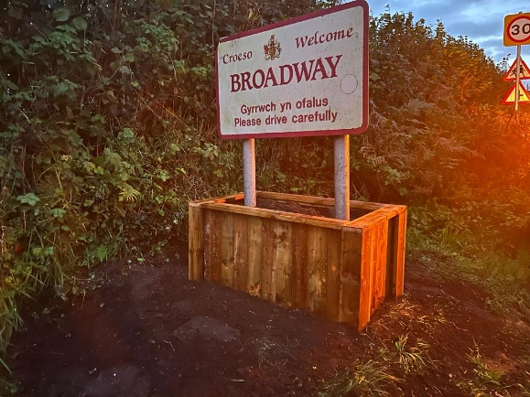

**New Noticeboard in Llansaint** – a new noticeboard has been provided during the year.

**Plans for 2024-25**

During the 2024-25 year the Community Council will continue to seek opportunities and work with its partners to support improvements to our community and to develop our services and facilities while maintaining those already in place on behalf of the community.

The Community Council also hopes to achieve the following:

* Provide hanging baskets for the square in Ferryside.
* Provide improvements to the Play Area facilities.
* Provide a beacon to mark the anniversary of D-Day.